OOP Lab Practical – 6

Name: Divyam Kumar

SAPID: 500083141

Roll No: R214220434

Batch: B2

**Title: Interface**

1. Write a program to create interface A, in this interface we have two method meth1 and meth2. Implements this interface in another class named MyClass.
2. Implement Multiple and multilevel Inheritance using Interface.
3. Write a program to create an Interface having two methods division and modules. Create a class, which overrides these methods.
4. Write a program to create interface named Test. In this interface, the member function is square. Implement this interface in Arithmetic class. Create one new class called ToTestInt. In this class use the object of Arithmetic class.

Question 1:

ALGORITHM:

Step 1: START

Step 2: Create interface A

Step 3: Define two function in A meth1() and meth2()

Step 4: Create class Myclass which implements A

Step 5: Override the methods meth1() and meth2() to print sum and product respectively

Step 6: Create main method

Step 7: Create instance of Myclass m

Step 8: Call meth1() and meth2()

Step 9: END

CODE:

interface A

{

void meth1();

void meth2();

}

class Myclass implements A

{

public void meth1()

{

int a =5,b=10;

System.out.println("Sum:"+(a+b));

}

public void meth2()

{

int a=5,b=10;

System.out.println("Product:"+(a*b));

}

public static void main(String[] args)

{

Myclass m = new Myclass();

m.meth1();

m.meth2();

System.out.print("Divyam\n500083141");

}

}

OUTPUT:

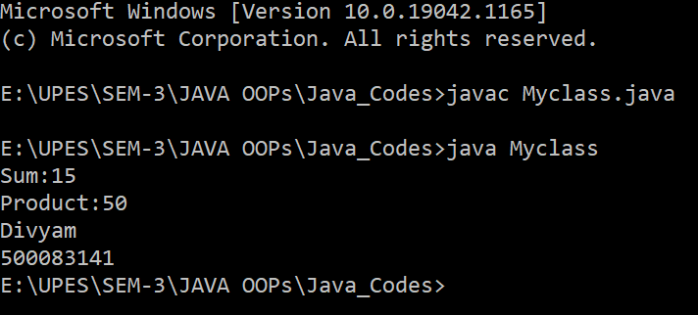

Question 2:

ALGORITHM:

Step 1: START

Step 2:Create interface f1

Step 3: Initialize dist = 25

Step 4: Define method void time()

Step 5: Create interface f2

Step 6: Initialize time = 10

Step 7: Define method void dist()

Step 8: Create Class Car which implements f1and f2

Step 9: initialize integer speed =50

Step 10: Override method dist() to print the distance

Step 11: Override method time() to print the time

Step 12: Create class base class Multiple which extends Car

Step 13: Define main method

Step 14: Create instance c of class Car

Step 15: Call methods c.dist() and c.time()

Step 16: END

CODE:

interface f1{

int dist=25;

public void time();

}

interface f2{

int time=10;

public void dist();

}

class Car implements f1,f2

{

int dist;

int speed =50;

public void dist()

{

dist=speed*time;

System.out.println("Distance:"+dist);

}

public void time()

{

int time=dist/speed;

System.out.println("Time:"+time);

}

}

class Multiple extends Car

{

public static void main(String args[]){

Car c =new Car();

c.dist();

c.time();

System.out.println("Divyam Kumar\n500083141");

}

}

OUTPUT:

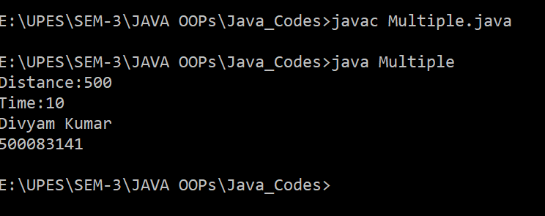

Question 3:

ALGORITHM:

Step 1: START

Step 2: Create interface MD

Step 3: Define method division(int n,m) and moudules(int a,b)

Step 4: Create class Calc which implements MD

Step 5: Override method division to print quotient of two number

Step 6: Override method moudules to print remainder of two number

Step 7:Define main method

Step 8:Create instance c of class Calc

Step 9:invoke method c.division(20,4) and c.moudules(10,3)

Step 10: END

CODE:

interface MD

{

public void division(int n,int m);

public void moudules(int a , int b);

}

class Calc implements MD

{

public void division(int n, int m)

{

System.out.println("Division:" +(n/m));

}

public void moudules(int a,int b)

{

System.out.println("Mod:"+(a%b));

}

public static void main(String[] args)

{

Calc c = new Calc();

c.division(20,4);

c.moudules(10,3);

System.out.print("Divyam\n500083141");

}

}

OUTPUT:

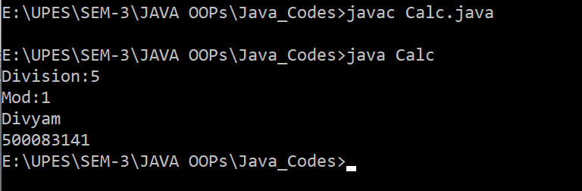

Question 4:

ALGORITHM:

Step 1: START

Step 2: Create interface Test

Step 3: Define method square()

Step 4: Create class Arithematic which implements Test

Step 5: Override method square to print “A square has 4 sides”

Step 6: Create base class Totestint which extends to Arithematic

Step 7:Define main method

Step 8: Create instance a of class Arithematic

Step 9: invoke method a.square()

Step 10:END

CODE:

interface Test

{

void square();

}

class Arthematic implements Test

{

public void square()

{

System.out.println("A square has 4 sides");

}

}

class Totestint extends Arthematic

{

public static void main(String[] args)

{

Arthematic a = new Arthematic();

a.square();

System.out.print("Divyam\n500083141");

}

}

OUTPUT:

